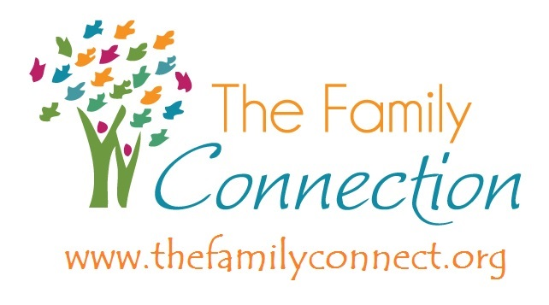

What to expect at a The Family Connection event (Family Learning Fun Night, Family Learning Fun Workshop, Parenting Classes, Parenting Workshops, etc.):

- It will be FREE.

- If you are attending a series, it will be 1 day per week for 2 hours for a set amount of weeks.

- You will receive free incentive items for coming and a free meal each time you attend. Depending on the weekly meeting/series, there may be a large prize at the end for excellent attendance, etc. Those types of extras are explained in the description details of the event.

- Most classes have free childcare (some of our morning classes do not because children will be in school and non-mobile infants are welcome to attend with their adult). See the description details.

- It will be meaningful and educational for Parents and Children.

- Your teacher is professionally certified to teach the evidence based curriculum you are learning.

- It will be a warm, friendly environment and a place to learn and grow.

- You will create friendships.

- We will respect and value your beliefs and family.

- We are reluctant to call our weekly meetings “parenting classes” because that has such a stigma attached to it. However, normalizing positive parenting practices is the first form of preventative care to shield children from adverse experiences and empower parents to be the best they can be!

- Parents have what it takes! We are here to support you!

ABRIENDO PUERTAS (10 weeks)
This series is culturally appropriate for Spanish-speaking clients with a healthcare component and flexible and colorful curriculum. This series focuses on positive parenting, community involvement, and learning about local resources for families to better their lives.

OPEN DOORS (10 weeks)
This curriculum is very easy to follow and flexible—partner organizations are encouraged to add relevant mini-presentations from healthcare professionals, social service workers, and other community workers with local resources available for their families. This series focuses on positive parenting, community involvement, and learning about local resources for families to better their lives.

MAKE PARENTING A PLEASURE (12 weeks)
A straight forward curriculum focusing on parent self-care, positive parent and child interactions and early childhood development information, with room for mini-presentations from community partners on health, nutrition, and mental health awareness.

PARENTING NOW (7 weeks)
A shorter series that captures Make Parenting a Pleasure’s main points. A straight forward curriculum focusing on parent self-care, positive parent and child interactions and early childhood development information, with room for mini-presentations from community partners on health, nutrition, and mental health awareness.

NURTURING PARENTING (12 weeks)
A versatile curriculum with many offshoots that include Parenting Teens, Teen Parents and Grandparents as Parents. The workbook holds a lot of information for parents to refer back to. Its core base focuses on parent self-care, positive parent and child interactions and early childhood development information, with room for mini-presentations from community partners on health, nutrition, and mental health awareness

NURTURING ABCS (7 weeks)
A condensed Nurturing Parenting curricula focusing on early childhood development and how to positively interact with a 0-4 year old developing child.

NURTURING FATHERS (13 weeks)
A support class specific to males with a trauma-informed, therapeutic curriculum that helps heal “father-shaped holes; “promotes healing through knowledge and self-care so participants can be positive male role models for children.

PASTA—PARENTING A SECOND TIME AROUND (8 weeks)
This curricula is specific to grandparent/caregiver relatives that are guardians of children or teens. Topics include information about child development of all ages and stages (ages 0-18), discipline and guidance, caring for yourself as a caregiver/guardian, rebuilding a family, living with teens, legal issues, and advocacy.

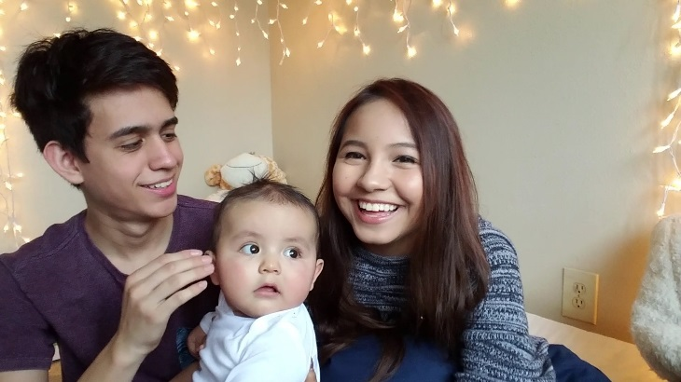

NURTURING TEEN PARENTS & THEIR CHILDREN (12 weeks)
These 12 weeks focus on preparing new teen parents. The series focuses on the importance of positive parent-child interactions starting at infancy. New teen parents are encouraged to pay close attention to the social, emotional, and physical development of their child. Attention is also focused on parent self-care, local resources for wrap around support, and early childhood development information, with room for mini-presentations from community partners on health, nutrition, and mental health awareness.

If you are seeing a class here that you would like to attend, please find it on our calendar: http://thefamilyconnect.org/events-calendar/

